Objective
The objective of this Procedure is to outline Configuration Management (CM) activities associated with the development and management of Products developed by Engineering.

Responsibilities

Vice President Engineering
The Vice President (VP) Engineering is responsible for the development and maintenance of this Procedure.

Design Assurance and Quality Engineering Manager
The Design Assurance and Quality Engineering Manager is responsible for the updating and distribution of this Procedure, as well as any required training.

Engineering Staff
This Procedure applies to all employees in the Engineering Group.

Definitions and Acronyms

Definitions
Term | Meaning
Article | A Part, Sub Assembly, Assembly or Line Replaceable Unit (LRU).
Baselines | A baseline is a single work Product or set of work Products that can be used as a logical basis for comparison. It defines a reference for future activities.  A baseline may also be established as the basis for subsequent select activities when the work products meet certain criteria.  There are a number of different baselines:  - Functional Baseline: initial specifications established; contract, etc.  - Allocated Baseline: state of work products after requirements are approved  - Developmental Baselines: state of work products amid development  - Product Baseline: contains the releasable contents of the project
Controlled Items | Controlled Items include the following:  - Drawings,  - Documents,  - Digital/Soft Copy Filenames,  - Parts, Sub-assemblies, and  - Articles.
Documents | Engineering will provide Documents that detail the following information (not exhaustive).  - Requirements: define project requirements.  - Product descriptions: describes the product.  - Test Plans, Procedures and Results: define testing of the product.  - Installation instructions: details on how to install the parts on an aircraft or component (i.e. seats).  - Regulatory documents: Maintenance Manuals, Wire Diagrams, Parts Lists, Electrical Loads Analysis, Weight and Balance reports, etc
Drawings | There are several different drawing types, as detailed below:  - Articles. These define how to manufacture or build the components of the Product.  - Kits: Define how the Articles shall be combined into a deliverable kit to the customer.  - Installation. These define how to install the components of the system on the aircraft.
Major Revision | A revision that is not a Minor revision (FAA); refer to 14 CFR §21.95 and 14 CFR §21.93 for a Type Design, and 14 CFR §21.319 for an article produced under a Parts Manufacturer Approval (PMA).
Minor Revision | A revision that is not affecting the fit, form or function (FAA).
Project | An activity or series of activities engaged in by a person or team to accomplish a specific goal
Type Design Data | All data resulting from design activities that are required to produce the product and show compliance to the applicable Type Certificate basis. Examples include drawings, specifications, material information, processes, test reports.

Acronyms
Acronym | Meaning
CI | Configuration Items or Controlled Items
CM | Configuration Management
DCE | Design Controlled Entity
Epicor | Enterprise Resource Planning (ERP) tool used by Burrana
FAA | Federal Aviation Administration
FCA | Functional Configuration Audit
LOP | Length of Program
LRU | Line Replaceable Unit
OEM | Original Equipment Manufacturer
PCA | Physical Configuration Audit
PMA | Parts Manufacturer Approval
QMS | Quality Management System
TSO | Technical Standard Order
VP | Vice President

Resources
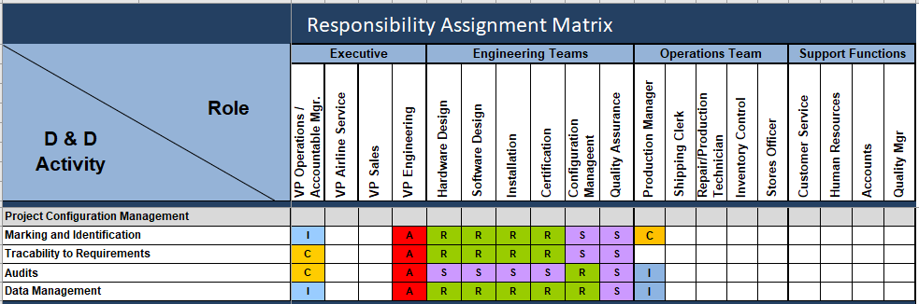
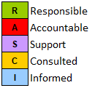

Process

Introduction
Burrana classifies Configuration Management (CM) as a cornerstone of its quality-based procedures, and shall be applicable to all quality, design, production, and service activities.
This document shall define the methods by which CM shall be applied to Engineering projects within or supervised by the Burrana Quality Management System (QMS) Manual.
The aim of this document is to detail the process to ensure that the identification and control of physical and functional attributes throughout the lifecycle of the Products produced by the Engineering Group. CM principles provide for establishing, documenting, and maintaining a Configuration Item’s (CI’s) functional, performance, and physical attributes in an orderly manner; managing changes to the attributes; and furnishing accurate information essential to the use, reproduction, maintenance, and re-procurement of the CI.
Table 1 shows the compliance to the Airbus Configuration Management requirements.
For designs developed by Engineering the CM of the Drawings and Documents shall follow the following processes:
- Design Activities to design the Product, creating approved Documents and Drawings as required by the Design process.
- Approved Design Drawings and Documents loaded into Burrana Enterprise Resource Planning (ERP) Tool (Epicor).
- Approved Documents saved in folder on Burrana Dropbox folders.
- Documents released to Operations and Customers.
These processes are shown in Figure 1. Underpinning these processes are the following activities.
Note that the Burrana Change Control process is described in ENG-P-836-01 Engineering Change Control Management.

Configuration Item Identification and Marking
All Configuration Items (CIs) shall have a unique identifier as detailed in ENG-W-812-05 Engineering Numbering System. Note that the Legacy Collins and digEcor numbering systems are detailed in ENG-W-812-07 and ENG-W-812-09 respectively.
Marking requirements for CIs are detailed on the relevant drawings as detailed in ENG-W-835-01 Engineering Drawings - Creation and Approval.

Traceability to Product Requirements
All Products have a System Requirements document that includes functional, interface and environmental requirements; refer to
ENG-W-822-02 Development of System Requirements, for details on developing these requirements.
All requirements shall be verified during the design phase as detailed in ENG-W-834-02, Design Validation and Verification.
Verification of airworthiness requirements for regulatory authorities require additional activities as detailed in ENG-W-835-07 Certification Documentation.

Baselines
A "baseline" is an agreed description of the attributes of a product, at a point in time, which serves as a basis for defining change. The identification of significant changes from the baseline state is the central purpose of baseline identification.
Significant states are those that receive a formal approval status. An approval status may be marked individually, when a prior definition for that status has been established by project leaders or signified by association to a position above or below the established baseline.
A baseline may also mark an approved configuration item, e.g. a project plan that has been signed off for execution. In a similar manner, associating multiple configuration items with such a baseline indicates those items as being approved.
Conversely, the configuration of a project may include one or more baselines, the status of the configuration, and any metrics collected. The current configuration refers to the current status, current audit and/or current metrics.
Baselines are controlled such that certain subsequent activities against work products in that baseline are either prohibited or permitted; these activities are selected, controlled and monitored. The following baselines are available to be used for Burrana products, depending on the Product and its complexity:
- Functional Baseline: initial specifications established; contract, etc.
- Allocated Baseline: state of work products after requirements are approved.
- Developmental Baselines: state of work products amid development.
- Product Baseline: contains the releasable contents of the project.
There are a number of developmental baselines available including:
- Proof of Concept.
- Proof of Design.
- Proof of Manufacture.
- Preliminary Design Review.
- Critical Design Review.
Each Project Plan will detail which baselines are to be used in that project.
Baselines are subjected to CM Audits.

Configuration Audits
Configuration Audits include an examination of specific actions performed against the Baseline, including, as appropriate:
- identification of individuals involved in any action,
- an evaluation of change within the baseline,
- (re-)certification for approval,
- accounting,
- metric collection,
- comparison to another baseline,
Configuration audits may be performed before the acceptance of a Product Baseline to assure compliance to the CI requirements and to assure that the CI accurately reflects the product as defined in the Type Design Data.
There are two types of Configuration Audits:
- Functional Configuration Audit (FCA); ensure that the CI meets it functional requirements as defined in the System Specification
- Physical Configuration Audit (PCA); ensure that the ‘as built’ CI conforms to the relevant drawings/documents.
PCA and FCAs are further described in ENG-W-834-01 Design Reviews.

Type Design Data
Type Design Data shall be managed in accordance with this document and any WIs referenced herein.

Data Storage
All Type Design Data shall be stored in the appropriate Dropbox folder as detailed in ENG-W-835-01 Engineering Drawings - Creation and Approval and ENG-W-812-06 Configuration Management. The documents shall be retained as required by the regulatory authority and or the customer and shall be made available on request.
The Airbus data storage requirements are shown in Table 1.
Table 1 Airbus Data Archiving Requirements
Data Type | Examples | Archiving Duration
Design Data, Design Reviews, Design Validation and Verification | Design Declaration, Minutes of Design reviews,  Qualification Test Reports, Qualification Test Results | Length of the Program (LOP)
Certification Compliance Documentation | Certification Reports, Certification / Developmental Ground Test Requirements, Certification Reports | Length of the Program (LOP)
Evaluation of Suppliers | Audit and Assessment reports, Quality Trends, Supplier Purchase orders | 6 Years
Instructions for Continued Airworthiness | Technical Publications | LOP + 3 years
Documents supporting the continued airworthiness obligations | Occurrence Reports | Length of the Program (LOP)
Design organisation Signatories | DOA Authorised authorities, technical signatories, Training and experience records | 2 years after leaving role or withdrawal of signature authorisation

Note Boeing data storage requirements shall be added at a later date, any existing data shall be archived until the requirements are included in this document.
In accordance with FAA AC 21-40A (Guide for obtaining a Supplemental Type Certificate) the FAA may, through a memorandum of agreement, require Burrana to maintain portions of the type design and substantiating data on their behalf. The FAA Certification Branch will instruct Burrana on what data is to be retained under the agreement, using FAA Order 8110.4 Appendix 10. Any data held under this agreement is permanent and must not be destroyed with the express written permission of the relevant FAA office.

Nomination and Approval Process
Personnel identified as having the relevant competencies can be nominated for internal authority by their Engineering Manager or VP Engineering. The application is to be discussed with the employee to ensure that they are willing to undertake the additional responsibilities. Refer to ENG-P-530-01 Technical Signatory Management.

Revision Control of Controlled Items
Revision control of Controlled Items is a key activity, as described in the following sections.

Major Revision (FAA)
The major revision is a high-level revision control, which provides a means by which an article, part or sub-assembly can show compatibility and traceability. A major revision change is triggered by a change in the component that affects fit, form or function of the component.
- The major revision status shall be used to meet the change management requirements of 14 CFR Part 21.319(2) for articles manufactured under a Parts Manufacturer Approval (PMA).
- The major revision status shall be used to meet the change management requirements of 14 CFR Part 21.619(b) for articles manufactured under Technical Standard Order (TSO).

Minor Revision (FAA)
For a minor Article revision, not affecting the fit, form or function, annotation shall not be expressed as a change to the part number, but to the revision number. The minor revision is a low-level revision control, which provides a means by which a part or sub-assembly shows compatibility and traceability.
- The minor revision status shall be used to meet the change management requirements of 14 CFR Part 21.319(b) for articles manufactured under a PMA.
- The minor revision status shall be used to meet the change management requirements of 14 CFR Part 21.619(a) for articles manufactured under a TSO authorization.

Part Number Change (OEM)
For Airbus, a part number change is required if a change meets any of the criteria detailed in the Part Number Change Criteria checklist in ENG-W-836-08.
For Boeing, a part number change is required when the change has an impact on form, fit or function of an existing LRU.

Amendment Change (Airbus)
An Amendment change is required if a change meets any of the criteria detailed in the Amendment Criteria checklist in ENG-W-836-08. Typically, these are changes that do not require a part number change but updated units are identified through an Amendment marking.

Other Changes (OEM)
Other changes are ones that do not:
- meet the criteria for part number or amendment changes (Airbus) or
- affect form fit or function and the modified unit is two way interchangeable with the existing unit. (Boeing).

New Equipment (Boeing)
Boeing have a process for requesting the approval of equipment with a new part number.

Transfer of Controlled Data to Operations
Design data shall be transferred to the Operations team using Epicor. The instructions on entering data into Epicor is defined in ENG-W-812-02. ENG-W-835-02 details the steps and checklist to transfer the data to Operations. Operations do not have access to uncontrolled data, only approved data in Epicor.

Configuration Management Plans
Burrana does not have a specific Configuration Management Plan (CMP) for each project/product. The CM suite of Processes and Work Instructions (WIs) details the CM requirements for each project. To satisfy Original Equipment Manufacturer (OEM) requirements a CMP will be created for all OEM Work packages; refer to ENG-W-812-08 OEM Configuration Management Plans.

Control of Non-Conforming Products
Refer to QC-P-870-01 for the process on how Burrana ensure that outputs that do not conform to Product requirements are identified and controlled to prevent unintended use or delivery. In addition, QA-P-1020-01 defines the processes to be followed whenever a non-conformance is identified.

Special Instructions
Burrana shall provide support to the Purchaser on request for the management of Special Instructions in accordance with applicable rules. Refer to ENG-W-835-13 Technical Publication Creation, Approval and Release.

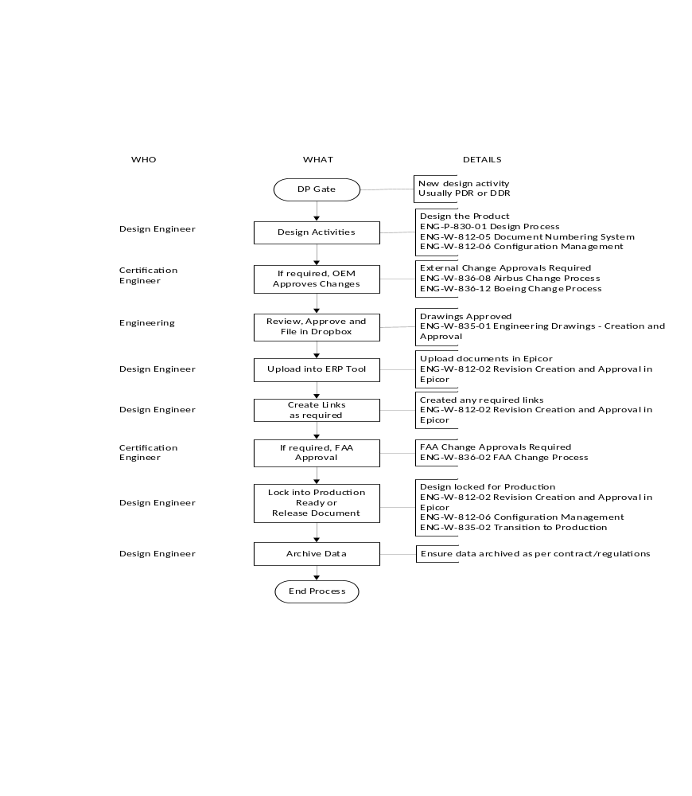
Figure 1 Internal Document and Drawing CM Process

Table 1 Airbus CM Compliance Matrix
Airbus Paragraph Reference | Supplier's Compliance Plan Paragraph Reference | Compliance Status Yes/No/NA | Where not compliant specify deviation or alternative solution; where NA specify reason
A1501 (Issue D) |  | NA
3.1.4 Configuration Management |  | NA | Section Header
01.0010.D Configuration Management Plan (CMP) and Product Configuration Change | ENG-P-836-01  This document | Yes
A1502 (Issue D) |  | NA
2.5 Type Design Data Management, Identification and Marking |  | NA | Section Header
02.2212.D Demonstration of compliance to product requirement | Section 5.3 | Yes
2.5.1 Type Design Data Management |  | NA | Section Header
02.2019.D Type Design Data | Section 5.6 | Yes
02.2025.D Assessment and classification of changes to Type Design | Section 5.6.3 | Yes
02.2020.C Design and Certification Data Retention | Section 5.6.1 | Yes
2.5.2 Identification and Marking |  | NA | Section Header
02.2021.D Identification and Marking – General | Section 5.2 | Yes
2.5.3 Co-ordination Between Design and Production |  | NA | Section Header
02.2023.D Transfer of Design Data | Section 5.6.4 | Yes
02.2024.C Assessment, classification and approval of non-conforming items | Section 5.8 | Yes
02.2146.D Special Instructions | Section 5.9 | Yes

External Designs
External designs are those where the approved design data is controlled by another entity, the Design Control Entity (DCE).
For non-approved products, the DCE may control their quality system in a manner acceptable to Burrana. While it is recommended that the system meet the requirements of an approved or a PMA product, this is not a mandatory requirement.
Approved products or products for which Burrana holds a form of Production Approval, the DCE must have in place quality, document and data control, and design change control systems which are approved by Burrana as a part of the production approval. While this document relates to the activities of the DCE it forms a part of the Burrana production approval and must be approved by Burrana.

Documented Information

Work Instructions
ENG-W-812-02 Revision Creation and Approval in Epicor
ENG-W-812-05 Document Numbering System
ENG-W-812-06 Configuration Management
ENG-W-812-07 Collins Legacy Drawing Numbering System
ENG-W-812-08 OEM Configuration Management Plans
ENG-W-812-09 digEcor Legacy Document Numbering Systems
ENG-W-822-02 Development of System Requirements
ENG-W-834-02 Design Validation and Verification
ENG-W-835-01 Engineering Drawings - Creation and Approval
ENG-W-835-02 Transition to Production
ENG-W-835-07 Certification Documentation
ENG-W-835-13 Technical Publication Creation, Approval and Release
ENG-W-836-02 FAA Change Process
ENG-W-836-08 Airbus Change Process
ENG-W-836-10 Change Control Boards
ENG-W-836-12 Boeing Change Process

Governing Documents
- AS9100
- AS9115
- AS9145
- FAA: 14CFR 21.137(k)
AC 21-40A: Guide for obtaining a Supplemental Type Certificate
- CASA: TBD
- Airbus: A1501, A1502, ABD0100 g2-2.7

Records
Epicor entries for all approved documents.

Metrics
Burrana makes use of organizational knowledge, lessons learned and experience with the activities associated with configuration management to determine opportunities and risks that need to be addressed and which can:
- Give assurance that the procedure can achieve its intended result(s).
- Enhance desirable effects and prevent or reduce undesired effects.
- Achieve improvement.
Whenever necessary this information is documented.

